**How to import Access db into R.**

**Introduction:**  In any enterprise, data is stored in many forms and at many different places. To analyse data quickly, it important to load data from various sources to R faster. This is an attempt to put entire instruction in very simple and concise language.

First, package RODBC should be installed

install.packages('RODBC')

Later load the package

library(RODBC)

A connection should be established to access DB using OdbcConnect

folder <- 'C:\\Users\\pande\\OneDrive\\Capstone project\\2014_customer_data.accdb'

folder is name and location of database

con <- odbcConnectAccess2007(folder)

Before establishing connection, make sure that access driver is installed. Click following link to establish connection

<https://www.microsoft.com/en-in/download/details.aspx?id=13255>

If you have Microsoft office of 32-bit, you should use 32-bit R to connect.

Following message indicates the issue that access in in 32-bit while R is of 64-bit.

In odbcDriverConnect(con, ...) :

[RODBC] ERROR: state IM002, code 0, message [Microsoft][ODBC Driver Manager] Data source name not found and no default driver specified

Hold ctrl key while launching R thru R studio and you will be routed to R selection panel where you can select bit of R: 64-bit or 32-bit.

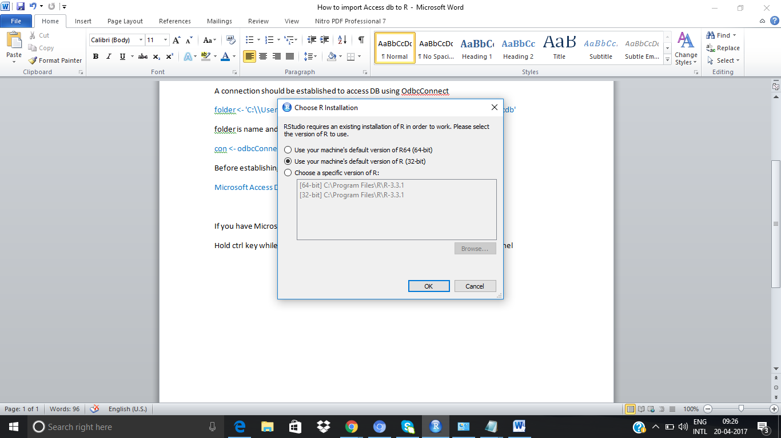

After connection is established, use following command to fetch entire table in R.

table_2014 <- sqlFetch(con, "Data_2014")

data_2014 is the access DB.

All tables available is ODBC connection can be found using following command

tables <- sqlTables(con)

Then click on table, which is present on environment tab.

Tables has many system tables and a table that has actual data.

data_2014 has actual data. This is illustrated in following screenshot.

